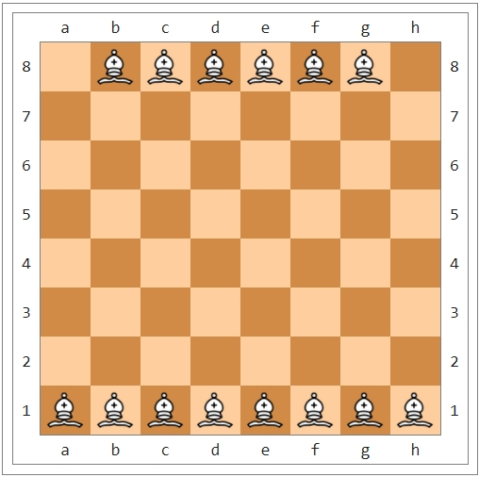

So, we place 14 bishops in total that do not attack each other.

Thank you

Student id : 201923250

Name : Kobilov Ilkhomjon